**Task:1. Database Design:**

**1. Create the database named "TechShop"**

create database TechShop;

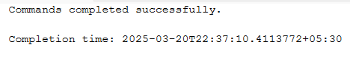

**2. Define the schema for the Customers, Products, Orders, OrderDetails and Inventory tables based on the provided schema.**

use TechShop;

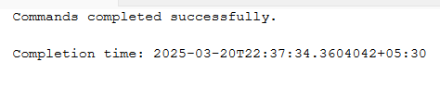

create table Customers(CustomerID int primary key, FirstName varchar(20),LastName varchar(20),Email varchar(20),Phone varchar(10),Address varchar(30));

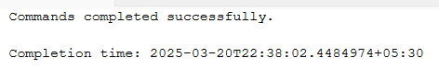

Create table Products(ProductID int primary key,ProductName varchar(15),Description varchar(30),price int);

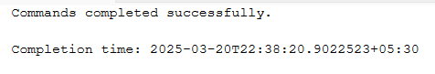

CREATE TABLE Orders(OrderID int primary key,CustomerID int,OrderDate date,TotalAmount int,foreign key (CustomerID) references Customers(CustomerID));

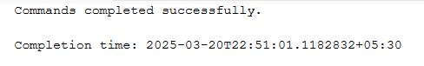

create table OrderDetails(OrderDetailID int primary key,OrderID int,ProductID int,Quantity int,foreign key (OrderID) references Orders(OrderID),foreign key(ProductID) references Products(ProductID));

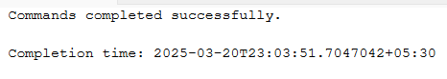

create table Inventory(InventoryID int primary key,ProductID int,QuantityInStock int,LastStockUpdate date,foreign key (ProductID) references Products(ProductID));

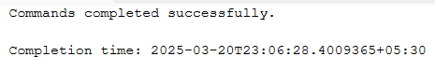

select name from sys.tables;

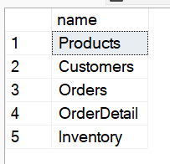

**3. Create an ERD (Entity Relationship Diagram) for the database.**

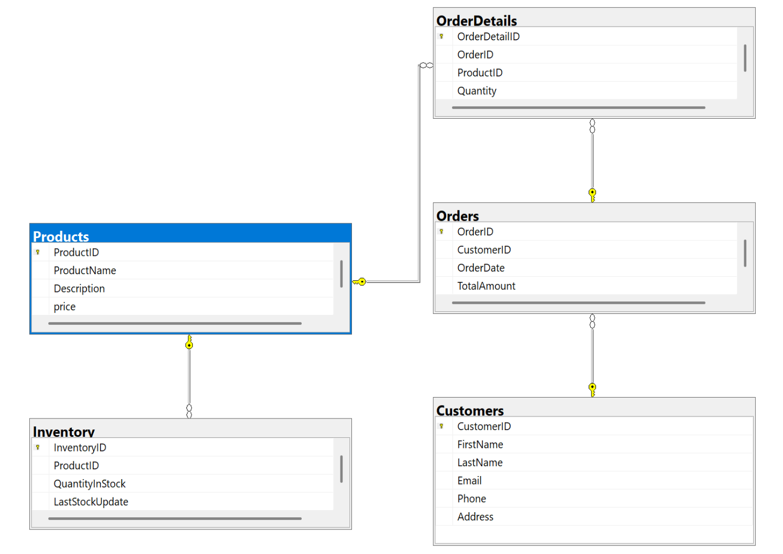

**4. Create appropriate Primary Key and Foreign Key constraints for referential integrity.**

Already done while creating but can be also done using alter command after creation of the table.

INSERT INTO Customers (CustomerID, FirstName, LastName, Email, Phone, Address) VALUES

(1, 'John', 'Doe', 'johnd@gmail.com', 9876543210, '123 Elm Street, NY'),

(2, 'Jane', 'Smith', 'janes@gmail.com', 8765432109, '456 Oak Avenue, CA'),

(3, 'Mike', 'Johnson', 'mikej@gmail.com', 7654321098, '789 Pine Road, TX'),

(4, 'Emily', 'Davis', 'emily@gmail.com', 9543210987, '321 Maple Lane, FL'),

(5, 'David', 'Wilson', 'davidw@gmail.com', 8432109876, '654 Cedar Blvd, IL'),

(6, 'Sarah', 'Brown', 'sarahb@gmail.com', 9321098765, '987 Birch Drive, WA'),

(7, 'James', 'Anderson', 'jamesa@gmail.com', 8210987654, '159 Redwood St, NV'),

(8, 'Laura', 'White', 'lauraw@gmail.com', 9109876543, '753 Aspen Way, CO'),

(9, 'Daniel', 'Martinez', 'daniel@gmail.com', 7898765432, '852 Spruce Ct, AZ'),

(10, 'Sophia', 'Taylor', 'sophiat@gmail.com', 6787654321, '369 Palm Ave, HI');

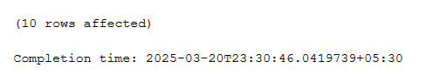

INSERT INTO Products (ProductID, ProductName, Description, Price) VALUES

(1, 'Laptop', '16GB RAM laptop', 75000),

(2, 'Phone', '128GB storage phone', 25000),

(3, 'Headset', 'Wireless headphones', 8000),

(4, 'Watch', 'Fitness smartwatch', 12000),

(5, 'Keyboard', 'RGB mechanical keyboard', 4500),

(6, 'Mouse', 'Wireless ergonomic mouse', 2000),

(7, 'Monitor', '27-inch 4K UHD', 35000),

(8, 'Printer', 'All-in-one printer', 15000),

(9, 'Tablet', '10-inch tablet', 30000),

(10, 'Speaker', 'Bluetooth speaker', 7000);



INSERT INTO Orders (OrderID, CustomerID, OrderDate, TotalAmount) VALUES

(1, 1, '2025-03-01', 75000),

(2, 2, '2025-03-02', 25000),

(3, 3, '2025-03-03', 8000),

(4, 4, '2025-03-04', 12000),

(5, 5, '2025-03-05', 4500),

(6, 6, '2025-03-06', 2000),

(7, 7, '2025-03-07', 35000),

(8, 8, '2025-03-08', 15000),

(9, 9, '2025-03-09', 30000),

(10, 10, '2025-03-10', 7000);

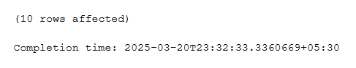

INSERT INTO OrderDetails (OrderDetailID, OrderID, ProductID, Quantity) VALUES

(1, 1, 1, 1),

(2, 2, 2, 2),

(3, 3, 3, 1),

(4, 4, 4, 3),

(5, 5, 5, 2),

(6, 6, 6, 1),

(7, 7, 7, 2),

(8, 8, 8, 1),

(9, 9, 9, 3),

(10, 10, 10, 2);

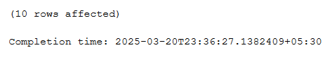

INSERT INTO Inventory (InventoryID, ProductID, QuantityInStock, LastStockUpdate) VALUES

(1, 1, 50, '2025-03-01'),

(2, 2, 30, '2025-03-02'),

(3, 3, 20, '2025-03-03'),

(4, 4, 25, '2025-03-04'),

(5, 5, 40, '2025-03-05'),

(6, 6, 35, '2025-03-06'),

(7, 7, 15, '2025-03-07'),

(8, 8, 10, '2025-03-08'),

(9, 9, 60, '2025-03-09'),

(10, 10, 45, '2025-03-10');

